PYTHON DATA ANALYTICS
CASE STUDY
NETFLIX MOVIES
AND TV SHOWS ANALYSIS
Exploring content type, genres, ratings, seasons and catalogue trends
━━━━━━━━━━━━━━━━━━━━━━━━━━━━━━━━━━━━

Prepared by | ____________________________
Programme / Class | ____________________________
Submitted to | ____________________________
Academic session | 2026
Prepared using Python: Pandas • NumPy • Matplotlib • Seaborn

Report Contents
1 | Problem Statement
2 | Dataset Description
3 | Data Cleaning Using Pandas
4 | Data Analysis Using NumPy and Pandas
5 | Data Visualization
6 | Findings
7 | Conclusion
 | References and Appendix

Project Overview
This case study examines a Netflix titles dataset to understand what kinds of content are listed, which genres and ratings appear frequently, how TV shows are distributed by season count, and how the catalogue has changed over time. The analysis uses a practical data workflow: inspect the CSV, check data quality, clean selected fields, calculate summary statistics, and communicate patterns through charts.
The report follows the prescribed case-study structure: problem statement, dataset description, Pandas-based cleaning, NumPy/Pandas analysis, visualisation, findings and conclusion.

1. Problem Statement
Streaming platforms contain large catalogues of films and television programmes. Looking through thousands of rows manually makes it difficult to see the overall shape of a catalogue or compare content categories consistently. This project uses the Netflix titles dataset to turn the raw CSV into a clearer summary of the catalogue.

Objectives
- Identify the number of Movies and TV Shows represented in the dataset.
- Inspect missing values, duplicate records and text formatting before analysis.
- Summarise release years and calculate basic numerical statistics using NumPy.
- Explore common genres, content ratings, countries, movie durations and TV-show season counts.
- Visualise the main patterns and communicate practical observations from the data.

Scope
The project is descriptive rather than predictive. It describes patterns in the supplied dataset; it does not measure Netflix viewing figures, popularity, audience satisfaction or the commercial success of individual titles.

2. Dataset Description
The project reads the file named netflix_titles.csv using Pandas. Each row represents a listed title, and the columns describe identifying information and attributes such as title type, director, cast, country, date added, release year, rating, duration, genre/category labels and description.
Column | Meaning
show_id | Identifier assigned to a title
type | Whether the title is a Movie or TV Show
title | Name of the title
director | Director or directors, where listed
cast | Cast information, where listed
country | Country or countries associated with the title
date_added | Date the title was added to Netflix
release_year | Year the title was released
rating | Content classification/rating
duration | Movie runtime or number of TV-show seasons
listed_in | Genre/category labels
description | Short description of the title
The content-type chart shows 6,131 Movies and 2,676 TV Shows, giving 8,807 titles represented in the displayed distribution. The exact cleaned row count and missing-value totals should be taken from the terminal output generated when the Python script is run locally.

3. Data Cleaning Using Pandas
Data cleaning was included before calculating statistics so that avoidable formatting issues and missing text fields would be less likely to disrupt the analysis.
Duplicate records: The script checks duplicated rows and removes exact duplicate records with drop_duplicates().
Text formatting: Leading and trailing spaces are removed from string values so that equivalent labels are treated consistently.
Date conversion: date_added is converted to a datetime value. Invalid or unrecognised date strings become missing values through errors='coerce'.
Numeric conversion: release_year is converted to a numeric type where possible; values that cannot be interpreted become missing.
Missing text fields: Missing values in selected text columns are replaced with the label 'Unknown' so those fields remain explicit in summaries.
Quality re-check: The script prints the dataset shape and missing-value counts again after cleaning.

Why these steps matter
Consistent text makes category counts easier to interpret, datetime conversion allows titles to be grouped by the year they were added, and numeric conversion makes release-year statistics possible. Replacing missing text with 'Unknown' also avoids silently treating an absent value as a real category.
A limitation of the current script is that 'Unknown' is also used for missing rating and duration values. These entries should be excluded from calculations where they are not meaningful, as the script does for genre, country and rating counts.

4. Data Analysis Using NumPy and Pandas

4.1 Numerical summary of release years
NumPy is used to calculate the mean, median, standard deviation, earliest release year and latest release year after missing release years are removed. The mean gives the arithmetic average, the median gives the middle value, and the standard deviation describes how widely release years vary around the mean. The actual numerical results are printed by the program when it runs.

4.2 Grouping and aggregation
Pandas value_counts() is used to count content types, ratings, genres, countries, season counts and years added. Genre and country fields can contain multiple comma-separated values, so str.split() and explode() separate those values before counting. This gives each listed genre or country an individual count rather than treating a whole comma-separated string as one category.

4.3 Movie runtime and TV-show seasons
For Movies, the numeric part of the duration field is extracted and interpreted as minutes. For TV Shows, the numeric part is extracted as the number of seasons. These analyses describe the entries with usable duration information; missing or unparseable durations are not included in the numeric summaries.

4.4 Correlation
The correlation matrix compares release_year with the year_added value derived from date_added. The displayed correlation is approximately 0.11, which indicates a weak positive linear relationship in the records used for this calculation. Correlation alone does not show that one variable causes the other.

5. Data Visualization
Matplotlib and Seaborn are used to produce labelled charts. Each chart is saved as a PNG image in the project_outputs folder, which makes the results reusable in a report or presentation. The figures below have been placed in the report from the screenshots supplied for this case study.

5.1 Movies versus TV Shows
The bar chart compares the two content types. The displayed counts are 6,131 Movies and 2,676 TV Shows. Movies therefore form the larger group in this dataset.
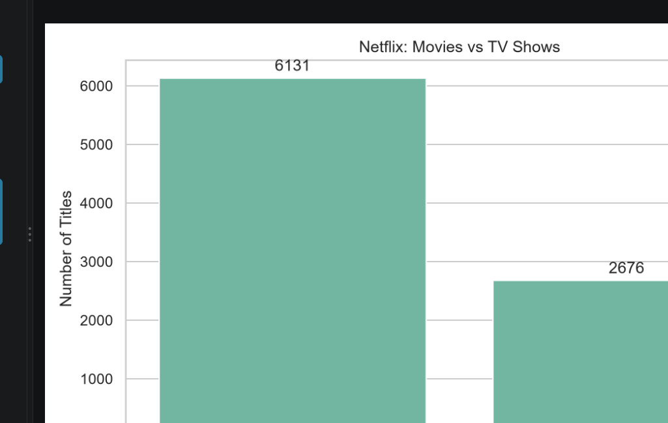
Figure 1. Distribution of Netflix titles by content type.

5.2 Most common genres
The horizontal bar chart compares the ten most frequently listed genres. International Movies appears at the top of the displayed chart, followed by Dramas and Comedies. Because titles may have more than one genre label, genre counts can overlap and should not be added together to estimate unique titles.
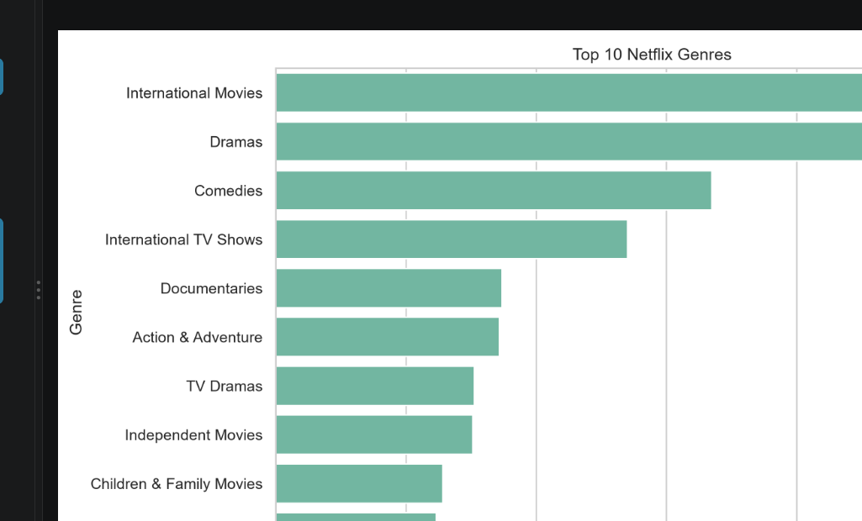
Figure 2. Ten most frequently listed genre categories.

5.3 Content ratings
The chart shows the ten most common non-missing content-rating labels. TV-MA is the largest category in the supplied figure, with TV-14 next. These labels describe content classifications, not a measure of audience ratings or title quality.
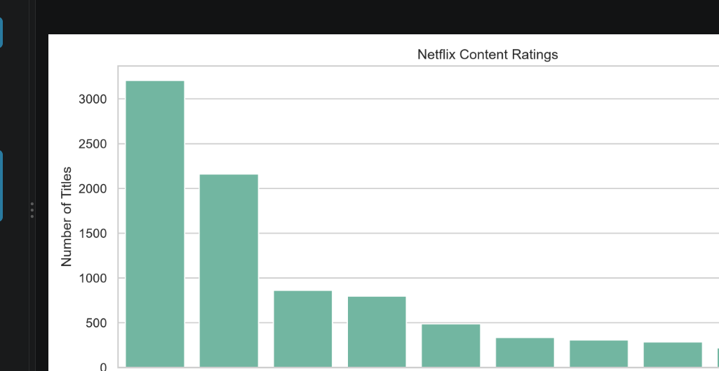
Figure 3. Distribution of the most common content ratings.

5.4 TV shows by number of seasons
The season-count chart shows that one-season shows are the most common group, followed by two-season shows. The counts become smaller as the number of seasons increases. This is a distribution of listed season counts, not evidence that a show was cancelled or successful.
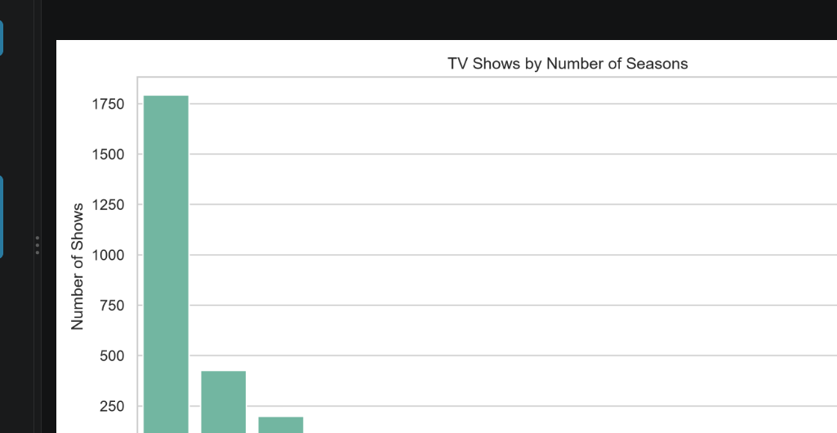
Figure 4. Number of TV shows grouped by season count.

5.5 Titles added to Netflix by year
The line chart summarises titles by the calendar year in which they were added to Netflix. The visible series rises sharply after the middle of the 2010s and reaches its highest displayed point around 2019, with lower counts in the following years shown. The final years can be affected by the coverage and date of the dataset snapshot.
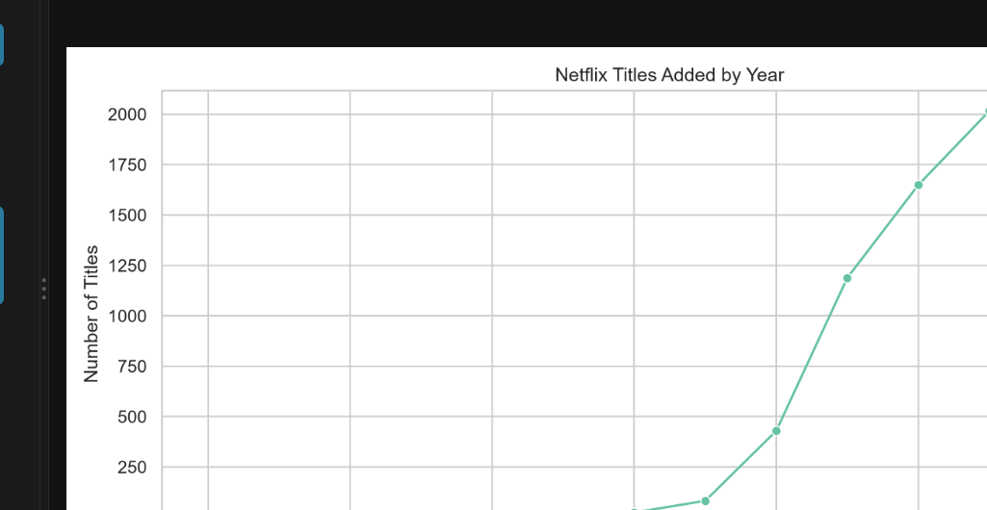
Figure 5. Number of titles added to Netflix by year.

5.6 Correlation heatmap
The heatmap displays the correlation between release year and year added. The off-diagonal value is approximately 0.11, a weak positive association. The diagonal values equal 1.00 because each variable is perfectly correlated with itself.
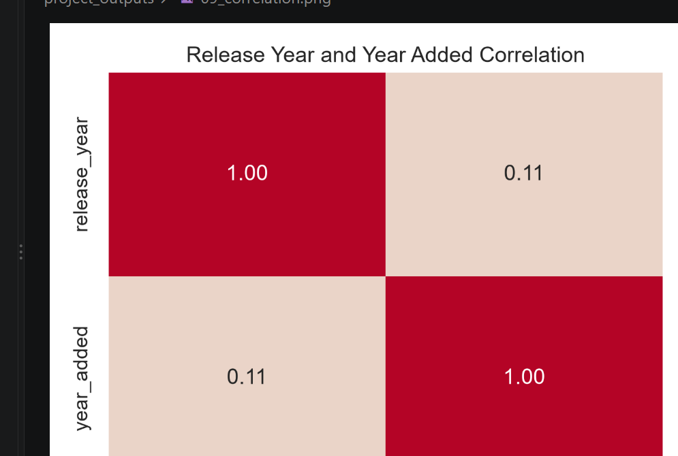
Figure 6. Correlation between release year and year added.

Other visualisations generated by the script
The code also saves a release-year trend chart, a top-countries chart and a movie-duration histogram. Those three images were not included among the screenshots supplied for this report, so they have not been reproduced here. They remain part of the script's intended output in the project_outputs folder.

6. Findings
- Movies are more numerous than TV Shows in the displayed content-type distribution: 6,131 compared with 2,676.
- International Movies is the most frequently displayed genre category in the top-ten genre chart.
- TV-MA is the most common rating category in the supplied rating chart, followed by TV-14.
- One-season TV shows form the largest season-count group in the supplied chart.
- The number of titles added per year rises markedly in the second half of the 2010s and peaks around 2019 in the displayed series.
- The release-year/year-added correlation is weak and positive at approximately 0.11; it should not be interpreted as a causal relationship.
- Genre and country fields contain multiple labels for some titles, so their category counts can overlap.
- The dataset contains missing information in several descriptive fields, making cleaning and explicit handling of missing values important before analysis.

Interpretation
Together, the charts provide a high-level picture of the catalogue rather than a complete measure of Netflix's business performance. They show how the supplied records are distributed across types and categories, while also highlighting why field definitions and missing-value handling matter when drawing conclusions from a real dataset.

7. Conclusion
This case study demonstrates a complete introductory data-analysis workflow using Python. Pandas was used to load, inspect and clean the CSV file, while NumPy supported numerical summaries. Matplotlib and Seaborn helped turn the results into charts that are easier to understand than raw rows alone.
The supplied outputs show that Movies outnumber TV Shows, International Movies is the leading genre in the displayed top-ten chart, TV-MA is the most common displayed rating, and one-season shows are the most frequent season group. The yearly additions chart shows a strong rise in the late 2010s, while the correlation between release year and year added is weak. These findings are descriptive and apply to the dataset snapshot used in this project.
The project could be improved by adding a compact summary table of exact statistics, including all nine generated figures in the final report, checking unusual values more deeply, and building an interactive dashboard for filtering by country, year, type or genre.

References
- Netflix titles CSV dataset supplied with the project (netflix_titles.csv).
- Pandas documentation: https://pandas.pydata.org/docs/
- NumPy documentation: https://numpy.org/doc/
- Matplotlib documentation: https://matplotlib.org/stable/
- Seaborn documentation: https://seaborn.pydata.org/

Appendix A — Tools and workflow
Tool | Use in this project
Python | Main programming language
Pandas | CSV loading, data cleaning, grouping and counting
NumPy | Mean, median, standard deviation, minimum and maximum
Matplotlib | Line charts, figure layout and image saving
Seaborn | Bar charts, histogram and correlation heatmap

Appendix B — Output files
The script saves figures in the project_outputs directory using descriptive filenames. Based on the provided code, the intended image files are: 01_content_type.png, 02_release_trends.png, 03_top_genres.png, 04_ratings.png, 05_countries.png, 06_movie_durations.png, 07_tv_seasons.png, 08_added_trends.png and 09_correlation.png.

